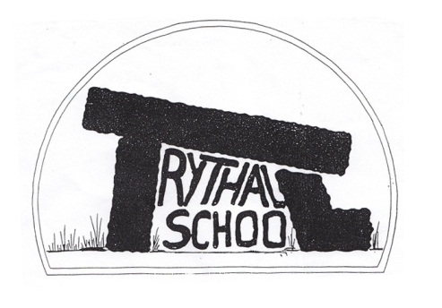
Trythall CP School
New Mill, Penzance
Cornwall. TR20 8XR
(01736) 362021
email: secretary@trythall.cornwall.sch.uk

Dear Parents,
Here at Trythall CP school, we recognise that there are occasions when it is appropriate to authorise an absence, such as when a pupil is genuinely too ill to attend school, has a medical appointment that cannot be taken outside of school hours or a request for leave has been agreed in exceptional circumstances.
However, the Government does not support parents taking children out of school unless the school agrees this is appropriate under ‘exceptional circumstances’. Any request for leave should be made in writing to the Headteacher using the school’s request form.
If you decide to still take your child out of school, without permission, you will be committing an offence under the Education Act 1996. We may refer the matter to Cornwall Council who may decide to take legal action against you. A penalty notice can be issued under Section 444A and 444B of the Education Act 1996. This carries a fine of £60 if paid within 21 days or £120 if paid after this but within 28 days. Failure to pay the penalty notice may result in Court action. Persistent absences not authorised by the school may result in a prosecution in the Magistrates Court, leading to fines up to £2,500 and/or custodial sentences. The Council may also apply for the costs incurred in taking the matter to Court.
You are welcome to contact the school to discuss any concerns you may have regarding this or if you feel you would like advice or support in helping your child attend more regularly. Trythall CP School is committed to maximising the education of all its pupils and aims to work with parents to ensure this can be achieved.

Yours sincerely
M.Strevens
Head Teacher

* For an offence under the Education Act 1996 Sec 444 (1) the maximum fine is £1000. For an offence under the Education Act 1996 Sec 444 (1A) the maximum fine is £2500 or imprisonment for a term not exceeding 3 months. Alternatively a penalty notice may be issued under Section 444A and 444B of the Education Act 1996. This carries a fine of £60 if paid within 21 days or £120 if paid after this but within 28 days. Failure to pay the penalty notice may result in Court action.

