Pre-school Charging Policy

Trythall CP School

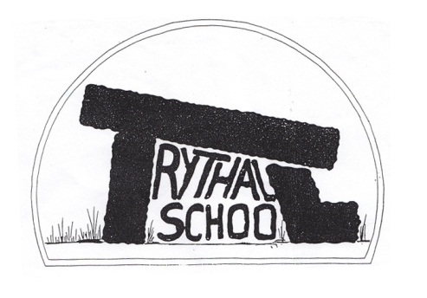

|  |  |  |
| --- | --- | --- |
| **Approved by:** | Governing Body | **Date:** [13 March 24] |
| **Last reviewed on:** | [13 March 24] | |
| **Next review due by:** | February 26 | |

**Session times**

Tuesday – Friday

9-12

9-1

9-3

Mondays 8.45-12.45 There are limited spaces for this session, which is run by the class 3 teacher. Bookings for Tuesday-Friday sessions are prioritised, but if there is a space available, places on Monday morning may be taken up, if your child is already booked in full time the rest of the week.

**Early drop off/late pick up**

Children may be dropped off at 8.45, by arrangement, either as part of a funded session or charged at £1.50.

If children are brought into the preschool building *before* their booked session start time or collected after 3pm, a flat charge of **£10** will be made. This is because staff will have to be paid extra to their contracted hours to look after them. (Please see late collection policy)

**3 and 4 year olds, additional to funded hours**

**Cost**: £5 per hour

**2 year olds:**

If available, we offer a limited number of 2 year old places for children from the term before the term in which the child turns 3.

**Cost**: £6 per hour

**For All Ages:**

**Minimum Time**: A minimum of two morning sessions per week must be booked.

**Cancellation**: The full charge will be made for arranged sessions that are cancelled without at least one months notice.

**Holding a place** (one month’s notice required): This will not always be possible but may be allowed at the discretion of the Senior Leadership. In this case a holding fee will be charged (50% of the normal charge).

**Exceptions**: No charge will be made if the school is closed.

Extra sessions can be booked at short notice if space is available. In the event of unusual cases it will be at the discretion of senior leadership