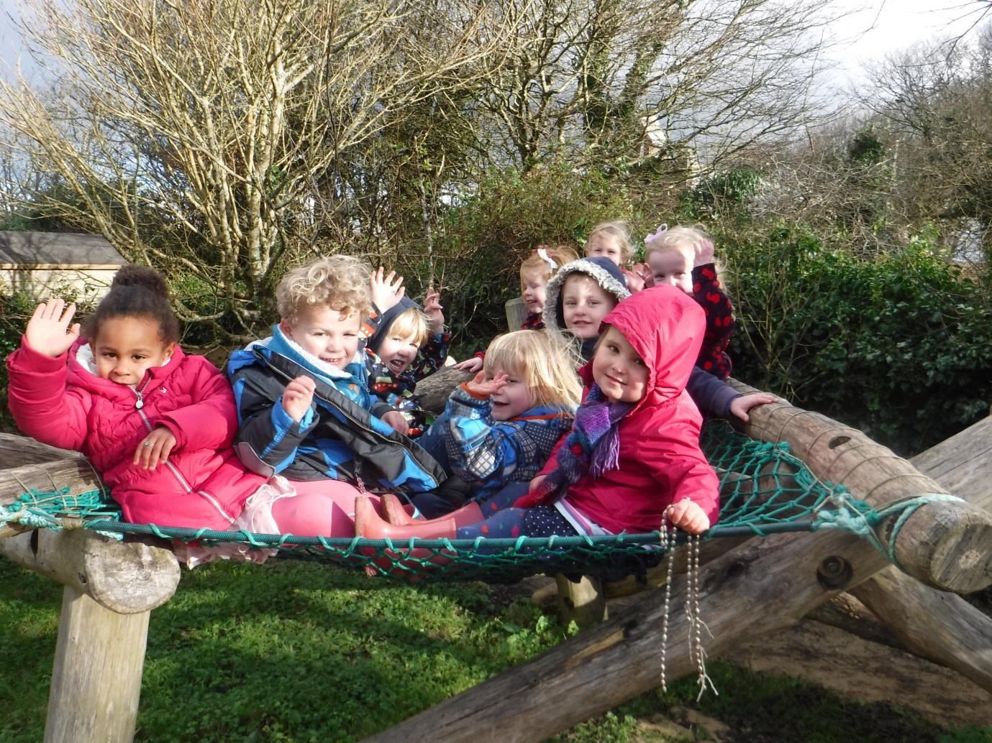

Welcome to
Trythall Pre-school

Introduction
This booklet outlines some important information about your child’s time at Trythall pre-school. If, after reading this booklet, you have any further questions, please do not hesitate to ask a member of the pre-school staff, the school secretary or the Headteacher.
Opening Hours
We are open during the school term only, excluding staff training days (5 per year). Our session times are 9am-12pm, 9am-1pm or 9am-3pm, Tuesday to Friday plus Mondays 9am -1pm. In addition you can arrange to drop your child off at 8.45am and/or collect them at 3.15pm.
Funding and fees
For some or all of these hours (see above) your child may be eligible for funding. Attendance beyond funded hours is chargeable at the current hourly rate.
All children are eligible for 15 free hours per week from the term after their third birthday. Some of these children will be eligible for 30 hours if both parents or a lone parent are working.
Some two year olds are also eligible for 15 hours funding per week.
Beyond your child's funded hours, fees are £4 an hour for three and four year olds, £5 an hour for two year olds.
Settling in

This is a very important step for you and your child and we do all that we can to make it as comfortable as possible for everyone involved. First of all we suggest you make an appointment to come and have a look around. If you like what you see, we will offer you a home visit, so that we can get to know each other. We find this really helps the settling in process as children start to see us as friends.

When your child starts at pre-school, you are very welcome to stay with them until they have made a bond with their key adult and feel that they will be safe when you go. This usually only takes a couple of sessions, but we can arrange a longer settling in period if necessary.

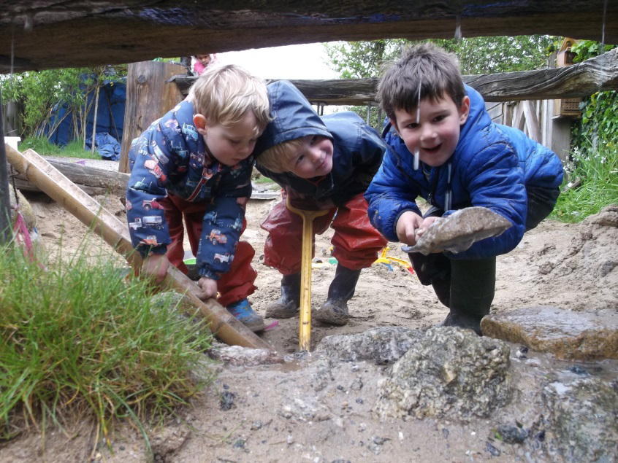

Key Child System

Each child has a key person who keeps a special eye on them. This adult is the main person to attend to their emotional and learning needs. The key person will make sure that provision for their key child’s play is planned with their individual needs in mind. They will feed back to you about your child’s progress at school and would be very grateful for any insight you can give them on how they are developing at home.

The staff with key children are:

Virginia Davies (Preschool leader) - Early Years Professional and Teacher
Sue Gamble - NVQ level 3
Hayley Gilbert - BA Hons Education and Curriculum Studies
We are all paediatric first aid trained.
There are other part-time staff who will also help your child play and learn.

Daily routine
We usually begin the day indoors, with construction toys, puzzles and games, sensory, roleplay and art and craft activities. Then, for a short time, all of the children are encouraged to join together for ‘carpet time’ for adult led activities such as dancing or listening games.
At mid morning snack time the children lay the table themselves and are encouraged to pass each other a choice of fruit and vegetables, followed by something savoury such as breadsticks, cheese or crackers. There is milk and/or water to drink.
After snack, we make use of our fantastic outdoor area, so at least half the session is spent outdoors.
We usually finish the session with some singing and a story.
12pm– 1pm Lunchtime.
Please provide a packed lunch or order a school dinner (£2.30) from Lucy before 9.30am on the day. Preschool children sit in a separate room from the rest of the school, accompanied by preschool staff. They are encouraged to eat the savoury part of their meal first, followed by fruit and finally any pudding or sweet treat if they are still hungry.

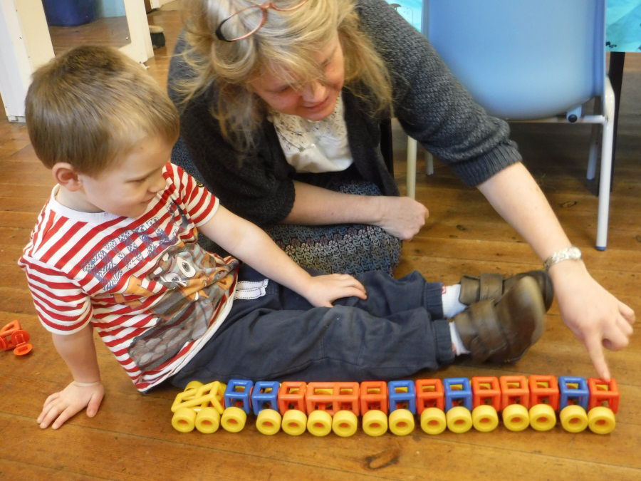

“Play is a child’s work”

Although to an adult it may look like you child is playing all morning, even during the adult led carpet time sessions, they are actually getting down to the serious business of learning! We are guided by the Early Years Foundation Stage, which is a legal framework that the government has introduced for all pre-school and reception settings. It is centred around the individual child’s unique path of development.
The staff set up an environment which provides opportunities for personal, emotional and social development (PSED), communication and language development (C&L) and physical development (PD).
Children will also be able to get involved in activities which help them develop in expressive arts (EAD), understanding the world (UW), literacy (L) and maths (M). Activities may include, for example, role modelling a turn taking scenario with puppets (PSED), talking about photos of a preschool trip to the airport (C&L), playing on the rope swing (PD), making a mud monster (EAD), fishing for tadpoles (UW), acting out the story of the three little pigs (L) or making a pattern with leaves and stones (M).

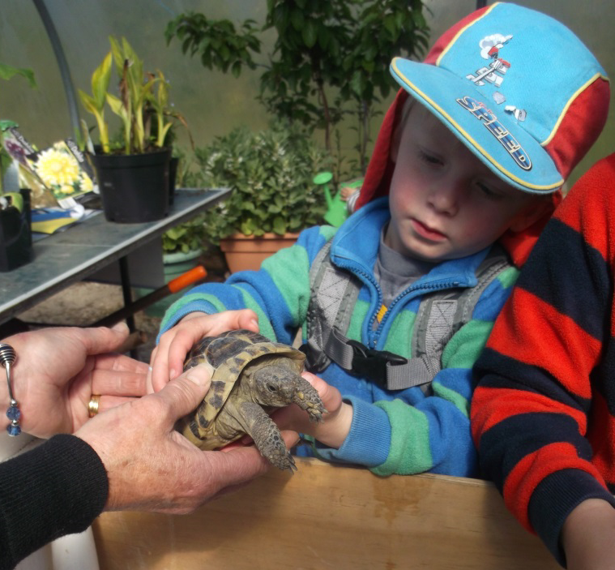

Learning Journeys
When your child does something significant, or shows that they have learnt something new, we record the moment in a photo or a written observation and put it into their ‘Learning Journey’ scrapbook. This Learning Journey is always available for you to look at. We would love it if you contributed to it too, with things your child has done at home. You can take the book home when your child leaves the pre-school.

Partnerships with parents/carers
We understand how important for the children it is, for us to have effective communications and good relationships with parents and carers. We will try and keep you informed as to what your child has been doing in daily informal chats. Do tell us what your child has been doing at home too. We will also meet with you at least twice a year to update you on your child’s progress at pre-school. However, if at any point you have any queries, concerns or want more information, do not hesitate to ask a member of staff, Lucy the secretary or Mat Strevens, the headteacher.

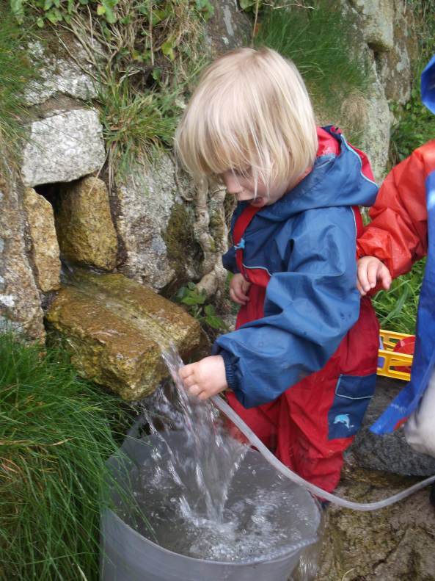

General Organisation
What to bring
As you child is almost certain to get wet, muddy or covered in paint, please dress them in old clothes that allow freedom of movement. Please provide velcro shoes or trainers because they allow children to run fast without tripping and they can learn to take them on and off without help from an adult.

We do spend a significant amount of our time outside so please ensure that your child has suitable clothing to suit weather conditions and we would be grateful if you could provide a pair of Wellington boots/spare shoes. However, we do provide waterproof clothing for going out in wet weather.
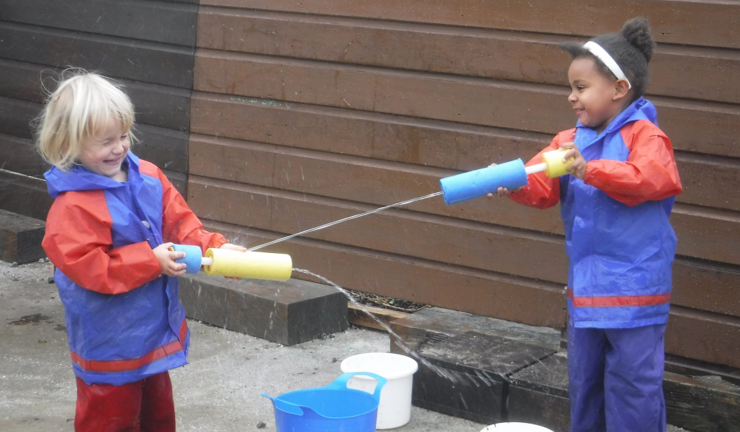

We also ask that you send in a spare set of clothes including pants and socks, in a bag each day just in case they get wet or messy. We will let you know if there are wet clothes to bring home.

Toys.

We respectfully ask that your child does not bring their own toys into preschool. It can be upsetting for your child if other children try to play with it. However, if your child has something special to show and share with us, please bring it in and give it to one of the staff to look after until such a time when your child can tell us about it (for example, a momento from holiday).

Collecting Your Child

Please could the person who drops off/picks up the child always report to the office on arrival.

Please contact the school (01736 362021) if you are going to be early dropping off or late picking your child up. (Please be aware that you will be charged for the extra childcare involved, in quarter of an hour blocks). Could you also inform Lucy in the office and one of the pre-school staff if someone other than you is collecting your child.

Sickness/Absence

We would be grateful if you could contact the school if your child is going to be absent. As a general rule , if your child has had a sickness/diarrhoea bug we would advise that they remain at home for 48 hours after they have stopped being sick, ( if the sickness is a reaction, for example, to eating too much party food and they are otherwise well then they can come straight back) .

Personal Information Forms.
When your child first comes to pre-school, you will be given a set of forms detailing your child's personal information. Please could you make sure that these are kept up to date and that we are informed if there are any changes.

We feel sure that you and your child will always hold dear your memories of your time at Trythall.
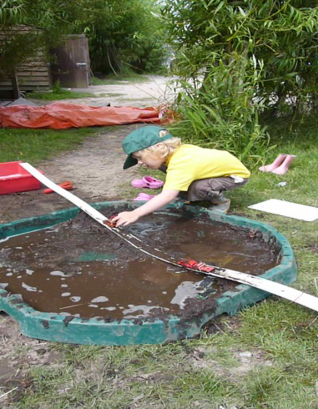

Concerns, Questions and Complaints.

Please ask any member of staff here if you have any further concerns or questions. We will do our best to answer them and if we don't know the answer we will endeavour to find out. All of the pre-schools' policies and procedures are available for inspection from the office and the complaints procedure is also on the school website.

We feel confident that, after your preschool experience, you may wish to secure a place in Trythall’s reception year. While we would love to see the pre-schoolers continue at Trythall, parents should be aware that enrolment at the preschool does not constitute an automatic place in Reception Class. Details of the Reception year application process are available from Lucy in the office or from the Local Authority.

More information, including policies, is also available on the school website at:

www.trythall.cornwall.sch.uk

- Tel: 01736 362021
- © Trythall Community Primary School. All rights reserved. 2015
- New Mill, Penzance, Cornwall, TR20 8X

